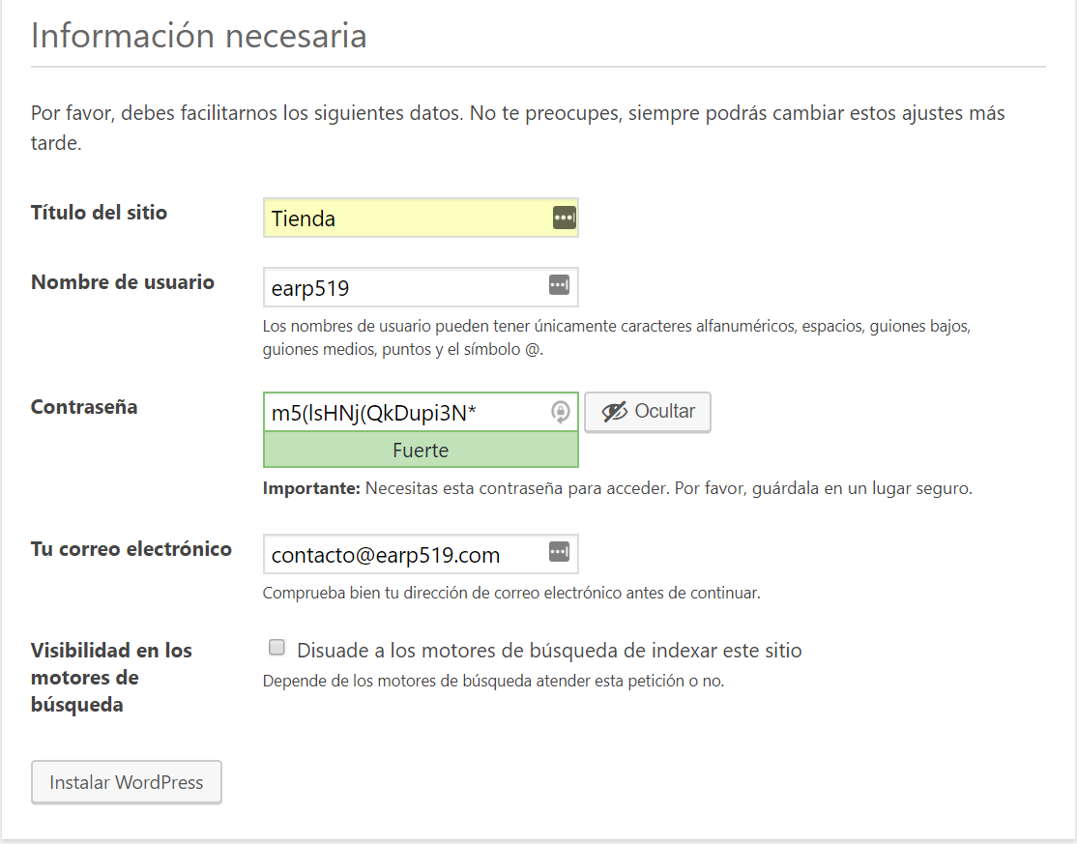

m5(lsHNj(QkDupi3N\*